
SEVENSTONE INVESTMENTS 115 (PTY) LTD
Manual in terms of The Promotion of Access to Information Act
2 of 2000 (PAIA).

February 2024

INDEX

1. Introduction

2. Our details

3. The Act

4. Applicable legislation

5. Access to records and availability

6. How to request access to records

7. Prescribed fees

8. Availability of our Manual

9. Updates to our Manual

10. Annexures - Forms

- INTRODUCTION
We are Sevenstone Investments 115 (Pty) Ltd, an authorised financial services provider (FSP) operating within the financial services industry in South Africa and registered with the Financial Sector Conduct Authority. We are licenced for Short-term Insurance: Personal and Commercial Lines, and Long-term Insurance: Life and Funeral.

Our client-base primarily consists of legal entities operating within South Africa, and our primary role is the development and provision of relevant products and supporting administration for end-clients/members of large organisations.
We shall use our reasonable best efforts to provide services in a commercially reasonable manner and with the care, diligence and skill that a prudent FSP would possess and exercise.
The purpose of this Manual is to tell you what type of information we have, and where applicable help you to access our information and any other information that we have.

- OUR DETAILS
Our details are as follows:
Registered Company Name: | Sevenstone Investments 115 (Pty) Ltd
Registration Number: | 2004/016523/07
Date of Incorporation: | 17 June 2004
FSP Number: | 11321
Business Address: | 1 Maja's Place, Cnr President Steyn & Benoni Road Benoni  1518
Postal Address: | P O Box 3430  Bedfordview  2008
Telephone: | 011 425 5922
Fax: | 011 425 5922
Website: | www.sevenstone.co.za
Director: | Ashley van Niekerk

We have appointed one information officer for our company.

Information Officer | Mr Ashley van Niekerk
Business and Postal Address | Same as above
Contact details | ash@sevenstone.co.za  Telephone: 011 425 5922

- THE ACT

3.1 Some key objectives of the Promotion of Access to Information Act (PAIA) are to promote transparency, accountability and effective governance of all public and private bodies.
3.2 The Information Regulator is responsible for the regulatory mandate functions relating to PAIA.
3.3 PAIA grants a requester access to records of our company, if the record is required for the exercise or protection of any rights. If a public body lodges a request, the public body must be acting in the public interest.
3.4 Requests in terms of PAIA shall be made in accordance with the prescribed procedures, at the rates provided. The forms and charges are dealt with in paragraphs 6 and 7.
3.5 Requesters are referred to the ‘Guide’ compiled by the Information Regulator, which is
available in a range of official languages and contains information for the purposes of
exercising constitutional rights.

Please contact the Information Regulator or visit their website for more information on how you can get access to information under PAIA, and to access the Guide.
The contact details of the Information Regulator are:

Postal address: P.O Box 3153, Braamfontein, Johannesburg, 2017
Physical address: JD House, 27 Stiemens Street, Braamfontein, Johannesburg, 2001
Phone number: 010 023 5200
Website: www.inforegulator.org.za
E-Mail address: enquiries@inforegulator.org.za (General enquiries)
helpdesk@inforegulator.org.za (Assistance)
POPIAComplaints@inforegultator.org.za (POPIA complaints)
PAIAComplaints@inforegulator.org.za (PAIA Complaints)
The Guide can also be made available upon request in writing to our Information Officer.

- APPLICABLE LEGISLATION
The records we hold for the purposes of PAIA are in terms of various laws; the main laws are as follows, although not limited to:
Ref Act
No 75 of 1997 Basic Conditions of Employment Act
No 53 of 2003 B-BBEE Act
No 55 of 1998 Employment Equity Act
No 130 of 1993 Compensation for Occupational Injuries and Disease Act
No 66 of 1995 Labour Relations Act
No 85 of 1993 Occupational Health and Safety Act
No 30 of 1996 Unemployment Insurance Act
No 68 of 2008 Consumer Protection Act
No 61 of 1973 Companies Act
No 25 of 2002 Electronic Communications and Transactions Act
No 37 of 2002 Financial Advisory and Intermediary Services Act
No 121 of 1998 Prevention of Organised Crime Act
No 38 of 2001 Financial Intelligence Centre Act
No 12 of 2004 Prevention & Combating of Corrupt Activities
No 33 of 2004 Prevention of Constitutional Democracy Against Terrorist & Related Activities
No 2 of 2000 Promotion of Access of Information Act
No 4 of 2013 Protection of Personal Information Act
No 89 of 1991 Value Added Tax Act
No 19 of 2020 Cybercrimes Act

- ACCESS TO RECORDS AND AVAILABILITY
We hold the following subjects and categories of records.
Please be advised that, as specified below, not all records are automatically available. The method of requesting information is detailed further on in this Manual.

Records | Subject | Availability
Public Affairs | Information on our services  Marketing material  Public corporate records  Media releases. | Freely available on our website at www.sevenstone.co.za and these records can also be requested from our office.
Company and Business: | Financial statements  Financial and tax records (Company & Employees)  Banking details and records  Asset register  Share register  Management accounts  Finance agreements  Rental agreements  Insurance arrangements  Minutes of board of directors’ meetings  Records relating to the appointment of directors, auditor, secretary, etc.  Operational records and internal correspondence  Standard operating procedures and company policies. | Not automatically available.  We are a Proprietary Limited (Pty Ltd)– and we are not required to disclose this information or make it freely available
Company and Business: | Documents of incorporation  Directors’ names. | Available from CIPC (Companies and Intellectual Property Commission).
Personnel | Records relating to current and previous staff  Contractual agreements with service providers and consultants. | Not automatically available.
Client information | Details about our clients, their contact information, their personnel, and our services and communications to them. | Not automatically available.

Description of the categories of data subjects (the individual to which the information relates) and of the information or categories of information relating thereto, in terms of the information we process:
Categories of Data Subjects | Personal Information that may be processed includes
Service providers and consultants | Names, registration number, VAT numbers, address, trade secrets and bank details.
Employees | Name, address, phone and personal e-mail contact, qualifications, salary, bank details, gender, race, religion, next of kin, medical details, and disciplinary matters.
Directors and shareholders | Same as ‘Employees’.
Our clients | Professional Indemnity, Personal Lines and Liability policyholders and their underlying members:  Name, ID number, company registration number, details of directors, e-mail address, physical address, telephone and cell phone numbers, details of assets with the risk address and security details, banking details, finance arrangements, claims history.

Our purposes for processing personal information, who we share information with, any transborder flows of such information, as well as our information security measures are detailed within our Privacy policy, which is available upon request from our office.

- HOW TO REQUEST ACCESS TO RECORDS

To facilitate the processing of your request, kindly:
6.1 Use the prescribed form, available on the website of the Information Regulator at
https://www.inforegulator.org.za/ under the section ‘PAIA / Forms’.
6.2 Address your request to our Information Officer.
6.3 Provide sufficient details to enable us to identify:
(a) The record(s) being requested;
(b) The requester (and if an agent is lodging the request, proof of capacity);
(c) The form of access required;
(d) (i) The postal address, email address or fax number of the requester in
the Republic;
(ii) If the requester wishes to be informed of the decision in any manner
(in addition to written), the manner and particulars thereof;
(e) The right which the requester is seeking to exercise or protect with an
explanation of the reason the record is required to exercise or protect the
right.
All requests will be carefully considered in terms of PAIA. Our Information Officer will notify you in writing as to whether your request for access has been approved or denied. You will receive such notification within 30 days after we have received the fully completed request form.
Please note that in certain cases, we may refuse you access to the requested record/s in order to protect others. This can include the following instances where we have a duty to:
- Protect the privacy of a third party
- Protect confidential information in terms of an agreement
- Protect the privacy and safety of a person or a juristic person
- Protect information in legal proceedings
You will however be notified of the reasons in writing should we refuse to provide the requested record/s to you.
If your request for access is denied or we do not handle your request in an acceptable manner, and after allowing us the opportunity to respond to and attempt to resolve the issue, you are still dissatisfied, you may lodge a complaint with the Information Regulator by completing a Complaint Form and submitting it to PAIAComplaints@inforegulator.org.za, or you can complete the online complaint form available at https://www.inforegulator.org.za/
The Complaint Form is available on the website of the Information Regulator at
https://www.inforegulator.org.za/ under the section ‘PAIA / Forms’.

- PRESCRIBED FEES
You will be required to pay a fee to us, as stipulated by law, before your request is considered or the records that you have requested are made available to you. Records may be withheld until the applicable fee/s have been paid.
You may have to pay a further access fee for any time that has exceeded the prescribed hours to search and prepare the requested record/s.
The prescribed fees are set out in Annexure B of the Regulations relating to the Promotion of Access to Information, 2021, as issued by the Department of Justice and Constitutional Development.
A copy of the Regulations can be made available upon request to our Information Officer.

- AVAILABILITY OF OUR MANUAL
Our Manual, in English, is available on our website and at our company office.

- UPDATES TO OUR MANUAL
We may update this Manual at any time and without notice to you whenever we make material changes to the current information, by making an updated version available via our website, and from the stated revision date our amended Manual will then be applicable.

ANNEXURES
FORM 2
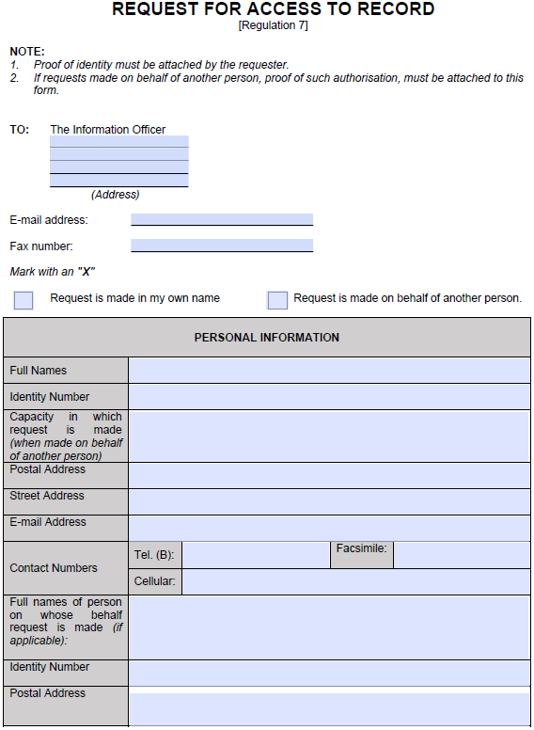

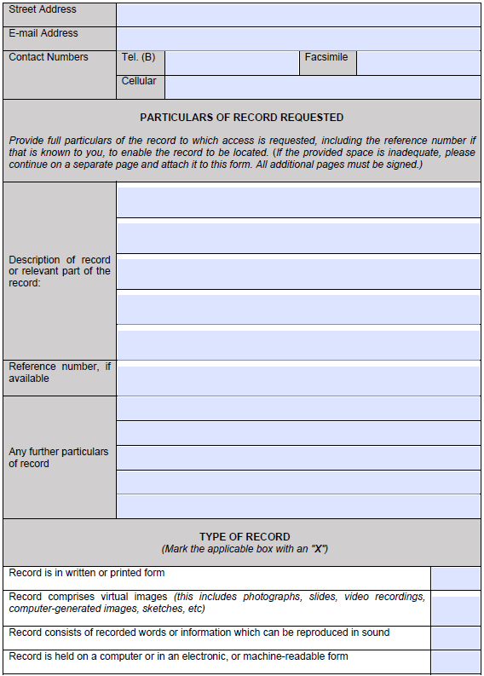

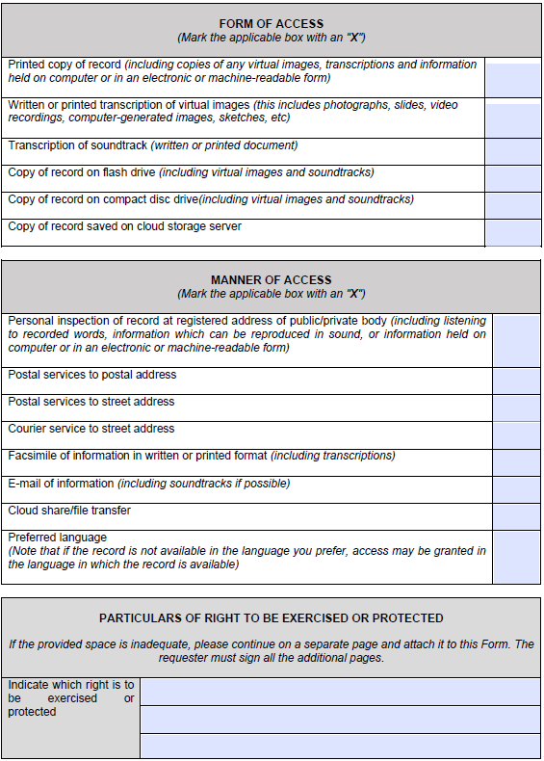

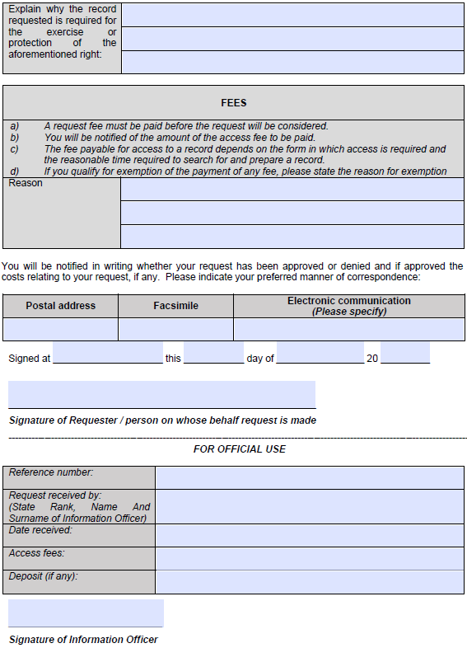

FORM 3
